PRESIDENT JOSEPH BIDEN:
THE MASCA CONNECTION

In 1984 the MIDDLE ATLANTIC STATES CORRECTIONAL ASSOCIATION convened its annual training conference at the Rehoboth Beach Convention Center in Delaware. It was the only time in its long history that it welcomed a future President of the United States as its keynote speaker – Senator Joseph Biden of Delaware.

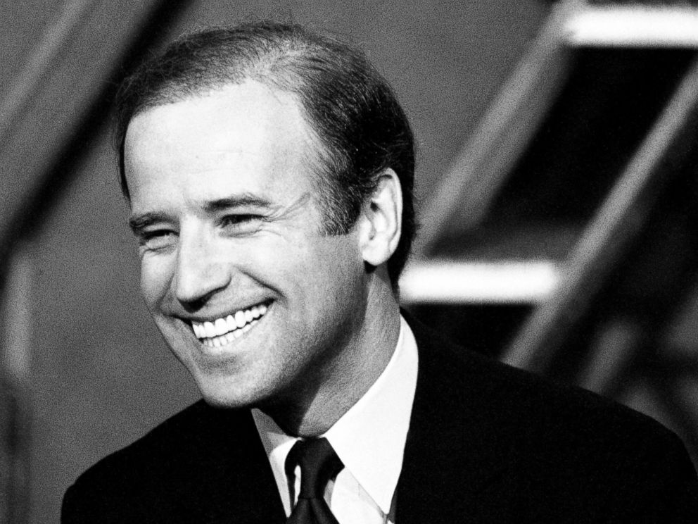

Senator Joseph Biden of Delaware appears on “Meet the Press” in
1984 just 3 weeks before his speech to MASCA in Rehoboth Beach
Biden delivered a spirited presentation. His appearance at the MASCA Conference was covered by THE MORNING NEWS in Wilmington, Delaware. They reported that: “Biden, who is co-sponsoring an anti-crime bill…said the legislation would establish a federal sentencing commission and calls for shorter sentences and equity in sentencing…The proposed sentencing structure calls for a sentence for any offense and if a judge deviated from the sentencing choices, he would have to qualify the decision. ‘What we’re trying to get in here is certainty in the system and equal application for equity in the system’, Biden said…Biden said he would like to see the federal government establish what could be likened to a national criminal justice institute, similar to the National Institutes of Health. He said that the federal government could focus on one aspect of corrections at a time, deal with the problem and, if a solution is found, pass it on to the states.”

The U.S. Sentencing Commission was created later that year under provisions of the Comprehensive Crime Control Act of 1984 and the sentencing guidelines went into effect in 1987. The legislation passed with strong bi-partisan support and was signed into law by President Ronald Reagan.

MASCA President James Morris of the District of Columbia presided over the 1984 event, which took place on May 20-23, 1984 with 394 persons in attendance. The conference theme was “Realistic Corrections: Proactive Approaches From Within”. The resort community of Rehoboth Beach was a popular destination for the hard-working professionals in the related fields of corrections, probation, parole, and juvenile justice who attended. Delaware Lt. Governor Michael Castle and Attorney General Charles Oberly also made presentations at plenary sessions. During the conference, MASCA adopted position statements supporting Affirmative Action in Corrections, Professional Training for Practitioners, and Support Services for Victims of Crime as well as opposing Mandatory Sentencing, Preventive Detention, and the Housing of Juvenile Offenders in Adult Facilities. At the conclusion of the conference, the MASCA Board of Trustees announced that its 1985 conference would be hosted by the State of Connecticut.

Rehoboth Beach Convention Center in Delaware

Senator Biden was re-elected as a U.S. Senator in 1984, 1990, 1996 and 2002, serving as Chairman of the Senate Judiciary Committee and later as Chairman of the Senate Foreign Relations Committee. Twenty-five years after his appearance at MASCA’s 1984 training conference, Joseph Biden resigned his Senate seat to become the 47th Vice President of the United States after the 2008 national election that chose Senator Barack Obama as President.

In 2013, as MASCA prepared to celebrate the 75th anniversary of its founding in 1938, Vice President Joseph Biden was invited to participate in its Annual Conference & Training Institute in Ocean City, Maryland but was unable to do so. He graciously sent a letter of congratulations to MASCA to mark its milestone anniversary. Regrettably, it arrived two weeks after the conference and the publication of a 75th anniversary booklet entitled “THE HISTORY OF MASCA 1938-2013: A LEGACY OF SEREVICE AND LEADERSHIP”.
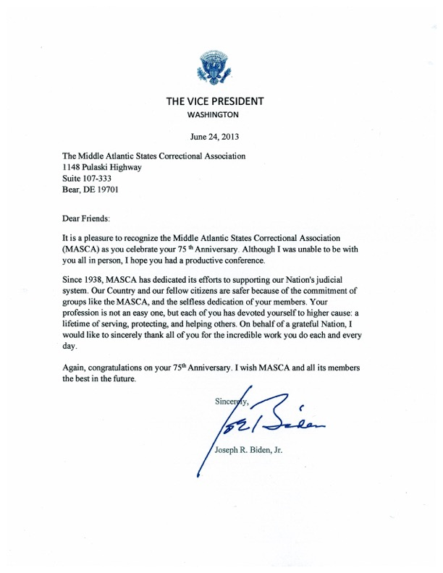

Vice President Joseph Biden extends warm congratulations
to MASCA in 2013 to mark the 75th anniversary of its founding
In his congratulatory letter, Vice President Biden noted that: “Our Country and our fellow citizens are safer because of the commitment of groups like the MASCA, and the selfless dedication of your members. Your profession is not an easy one, but each of you has devoted yourself to higher cause: a lifetime of serving, protecting, and helping others. On behalf of a grateful Nation, I would like to sincerely thank all of you for the incredible work you do each and every day.”

Eight years later on January 20, 2021 Joseph Biden was inaugurated as the 46th President of the United States, having been elected on November 3, 2020.

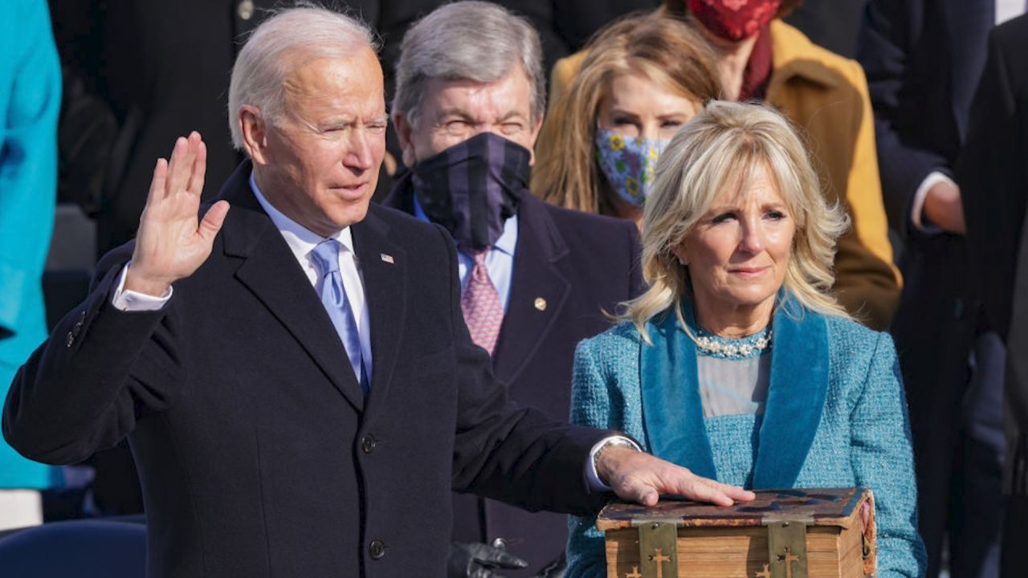

Joseph Biden is sworn in as the 46th President of the United States

MASCA has welcomed many distinguished and notable speakers to its annual training conferences over eight decades. Yet MASCA’s historic connection to the 46th President of the United States stands out as a memorable and exceptional milestone.

________________________________________

Anthony J. Czarnecki
M ASCA President: 1997-1999
MASCA Executive Director: 2009-2015
Editor, THE HISTORY OF MASCA: 1938-2013

