M ASCA

Middle Atlantic States Correctional Association
Connecticut • Delaware • District of Columbia • Maryland • New Jersey • New York • Pennsylvania

September 2, 2020

Dear Commissioner Quiros,

On behalf of the Board of Trustees of the Middle Atlantic States Corrections Association (MASCA), I wish to extend our congratulations to you on your recent appointment as the Commissioner for the Connecticut Department of Corrections. We are so happy for you, specifically as a past Executive Board Member of MASCA.

The commitment and leadership you've shown over 30 + years – which began as a Correction Officer, various Uniformed titles up to Warden, and then Deputy Commissioner, to Commissioner - will undoubtedly serve CTDOC well during these historically challenging times, which have impacted our lives and our industry.
As you are aware. The Middle Atlantic States Correctional Association (MASCA) is dedicated to promoting the highest standards of excellence and professionalism in criminal and juvenile justice by creating a support system for professionals at all levels in the correctional system. We have provided an educational forum for networking, problem-solving, and leadership development across state boundaries. During these demanding times we continue to promote the public image of institutional and community corrections through various platforms.
I look forward to personally meeting and working with you on global Correctional matters to include many of MASCA' s strategic priorities for the years ahead - bringing solidarity and cooperation across the profession, providing leadership to advance, and influencing our industry to achieve better outcomes. Each, naturally, resonates with MASCA and its membership.
This past year, our members have enjoyed the opportunity to participate with several professional organizations affiliated to MASCA exploring cutting edge services. In doing so, we were able to offer expertise for the development of an evidence -based opinion document that have framed issues on global needs in this area.
We hope MASCA will have further opportunities to collaborate with CTDOC on such important issues during your tenure.
Many exciting opportunities await you, and we wish you every success and professional fulfilment in your new
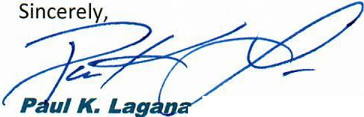
Role. During our last Board meeting we voted to provide ALL corrections agencies in our jurisdiction the opportunity for all staff to become Agency Members, which I personally extend to you at this time.

, Warden - Bucks County Department of Corrections President Middle Atlantic States Correctional Association
1730 South Easton Road Doylestown., PA 18951
Office Tel: 215.345.3798

